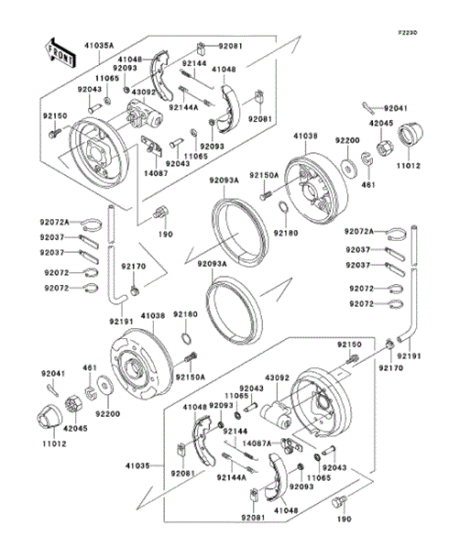

LOCATION | PART DESCRIPTION

190 | BOLT-UPSET-WS, 10X16  Part Number: 190BA1016Required per assembly: 8 |  | $4.15$2.85  Add to cart
461 | WASHER-SPRING, 18MM  Part Number: 461DA1800Required per assembly: 2 |  | $2.72$1.68  Add to cart
11012  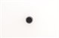 | CAP, WHEEL  Part Number: 11012-1969Required per assembly: 2 |  | $5.23$3.55  Add to cart
11065 | CAP  Part Number: 11065-1175Required per assembly: 4 |  | $4.58$3.14  Add to cart
14087 | RETAINER ASSEMBLY, RH  Part Number: 14087-1001Required per assembly: 1 |  | $24.76$22.51  Add to cart
14087A | RETAINER ASSEMBLY, LH  Part Number: 14087-1002Required per assembly: 1 |  | $24.76$22.51  Add to cart
41035 | PANEL ASSEMBLY, BRAKE, FR, LH  Part Number: 41035-1516Required per assembly: 1 |  | $508.76$462.51  Add to cart
41035A | PANEL ASSEMBLY, BRAKE, FR, RH  Part Number: 41035-1517Required per assembly: 1 |  | $508.76$462.51  Add to cart
41038 | DRUM, FRONT BRAKE  Part Number: 41038-0034Required per assembly: 2 |  | $329.88$314.89
41048  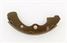 |  | SHOE-BRAKE  Part Number: 41048-1134Required per assembly: 4 | $18.70$13.87  Add to cart
42045 |  | NUT, CASTLE, 18MM  Part Number: 42045-018Required per assembly: 2 | $8.97$6.75  Add to cart
43092 |  | CYLINDER, FRONT BRAKE PANEL  Part Number: 43092-1054Required per assembly: 2 | $157.04$142.76  Add to cart
92037 |  | CLAMP  Part Number: 92171-0652Required per assembly: 4 | $2.44$1.51  Add to cart
92041 |  | COTTER, 4.0X35  Part Number: 92041-1053Required per assembly: 2 | $3.57$2.41  Add to cart
92043 |  | PIN  Part Number: 92043-1636Required per assembly: 4 | $3.92$2.71  Add to cart
92072 |  | BAND, L=123  Part Number: 92072-030Required per assembly: 4 | $4.66$3.18  Add to cart
92072A |  | BAND, L=149  Part Number: 92072-031Required per assembly: 2 | $4.66$3.18  Add to cart
92081 |  | SPRING, SHOE CLAMP  Part Number: 92081-1904Required per assembly: 4 | $7.53$5.73
92093 | SEAL  Part Number: 92093-1532Required per assembly: 4 | $8.07$6.11  Add to cart
92093A  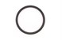 | SEAL, BS184.8X13.5ZS  Part Number: 92093-1543Required per assembly: 2 | $115.67$105.15  Add to cart
92144 | SPRING, BRAKE  Part Number: 92144-1300Required per assembly: 2 | $7.79$5.91  Add to cart
92144A  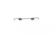 | SPRING, BRAKE  Part Number: 92144-1301Required per assembly: 2 | $7.79$5.91  Add to cart
92150 | BOLT, FLANGED, 6X12  Part Number: 92150-1166Required per assembly: 4 | $4.09$2.81  Add to cart
92150A | BOLT  Part Number: 92150-1366Required per assembly: 8 | $7.49$5.70  Add to cart
92170 | CLAMP  Part Number: 92170-2042Required per assembly: 2 | $1.28$0.86  Add to cart
92180  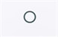 | SHIM, 25.2X32.5X0.6  Part Number: 92180-1353Required per assembly: 2 | $2.12$1.34  Add to cart
92191  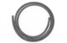 | TUBE, 4.7X9.5X1480  Part Number: 92191-1615Required per assembly: 2 | $7.36$5.60  Add to cart
92200 | WASHER, 18.5X52X4.5  Part Number: 92200-1474Required per assembly: 2 | $7.53$5.73  Add to cart

